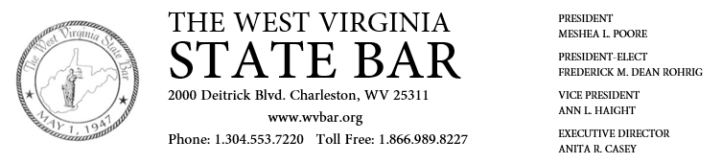
_____________________________________________________________________________________

To: IOLTA Participating Financial Institutions
From: The West Virginia State Bar
Date: August 2017

As reported last month, the new IOLTA database has been implemented on our membership portal. Attorney members will now be reporting their IOLTA accounts within the new system in an effort to centralize and improve our IOTLA tracking.
Currently, the process by which financial institutions remit to the Bar will not be affected, please continue submitting you remittance forms online at https://www.mywvbar.org/remittance. However, in the coming months, usernames and passwords will be issued to each individual institution which will provide access to the new system and require a new and finalized submission method. We expect to have the system fully implemented within the next few months.
Please feel free to contact our IOLTA administrator, Tyler Shoub, at shoubt@wvbar.org or 304- 553-7239 or our IT Director Mike Mellace at mellacem@wvbar.org or 304-553-7223 with any questions about the database. Please continue to contact the Bar’s Director, Anita Casey, at caseya@wvbar.org or 304-553-7228, with any legal questions regarding the IOLTA program.

ioltamonthly_8_2017 - copy.doc

